CMPG 325 - Computer Networks
Individual Semester Project - Milestone 2 Report
Client Implementation Review - Due 2 October 2026
Field | Detail
Student | Magwatane, T (42710677)
Project ID | CMPG325-2026-034
Client | Tau Metalworks & Engineering Supplies (Potchefstroom)
Addressing block | 172.30.16.0/23
Assigned challenge | HTTP/Web Server (internal web service hosting)

Executive Summary
This report documents the implementation, configuration and verification of the Milestone 1 network design for Tau Metalworks & Engineering Supplies in Cisco Packet Tracer. The implemented architecture uses an extended-star hierarchy centred on the Layer-3 CORE-SWITCH, with departmental and functional access switches providing the edge connectivity. Eight VLANs are implemented: Administration (10), Sales (20), Engineering (30), Production (40), Warehouse (50), Servers (60), CR2/New Floor (70), and Management (99). The 172.30.16.0/23 addressing plan is retained, with inter-VLAN routing provided through Core switch SVIs and end-user addressing supplied centrally by DHCP.
The assigned networking challenge, an internal HTTP/Web Server, is implemented on SRV-HTTP in VLAN 60 using the static address 172.30.17.66. Connectivity to the server was verified from Administration, Engineering and CR2, demonstrating communication across VLAN boundaries. LACP EtherChannel Po1 was also verified between CORE-SWITCH and SW-SERVER, with both physical member links bundled and operational. DHCP bindings were confirmed for all six DHCP-enabled user VLANs, while the server remained statically addressed.
Verification was evidence-led rather than configuration-only. The report records VLAN and SVI status, trunk and EtherChannel operation, DHCP leases, inter-VLAN connectivity, HTTP access and Management VLAN reachability. An initial packet loss during one inter-VLAN ping was investigated as ARP resolution behaviour; subsequent packets succeeded, and the repeat management test achieved 100% success. DNS was intentionally outside the implemented scope because the assigned challenge requires direct HTTP access to the internal server rather than name resolution.
Overall, the evidence presented in this report demonstrates that the Milestone 2 implementation is functionally aligned with the approved Milestone 1 design and that the required networking challenge has been implemented and tested in a controlled Packet Tracer environment.

1. Introduction
Milestone 2 implements, in Cisco Packet Tracer, the network design approved at Milestone 1 for Tau Metalworks & Engineering Supplies. The design retains the extended-star, hierarchical architecture established previously: a Layer-3 Core multilayer switch performs inter-VLAN routing and hosts a centralised DHCP service, while each department or functional area connects through its own Layer-2 access switch. VLAN segmentation continues to isolate departmental broadcast traffic, and the client's change request (CR2) is served by a dedicated access switch and VLAN. The assigned technical challenge, an internal HTTP/Web server, has been implemented, verified, and is reachable from multiple VLANs. In response to the availability design constraint, the server switch is connected to the Core over a redundant LACP EtherChannel bundle. This report presents the completed implementation, the configuration applied to each device, and the testing evidence gathered to confirm correct operation.
1.1 Aim and Objectives
The aim of Milestone 2 was to translate the approved Milestone 1 network design into a functioning Cisco Packet Tracer implementation and to demonstrate, using configuration and connectivity evidence, that the resulting network satisfies the specified technical requirements.
The objectives were to: (1) implement the planned VLAN structure and departmental segmentation; (2) configure the Core multilayer switch as the Layer-3 routing point; (3) provide DHCP addressing for the required user VLANs; (4) implement the internal HTTP/Web Server challenge in VLAN 60; (5) provide the CR2/New Floor segment through VLAN 70; (6) establish LACP EtherChannel connectivity between the Core and server switch; and (7) verify the implementation through repeatable tests and documented troubleshooting.
1.2 Implementation and Verification Method
The implementation followed a configuration–verification cycle. First, the physical and logical topology from Milestone 1 was reproduced in Packet Tracer. Second, VLANs, SVIs, trunks, DHCP, the HTTP server, CR2 and EtherChannel were configured. Third, show commands were used to verify the operational state of the network rather than relying solely on configuration entries. Finally, end-to-end pings, DHCP lease checks and browser-based HTTP tests were performed from representative VLANs. Where an initial test did not provide complete success, the behaviour was investigated and a repeat test was used to establish the final operational result.
This approach provides two complementary forms of evidence: configuration/state evidence, which demonstrates that the network devices are configured as intended, and functional evidence, which demonstrates that hosts can actually communicate through the implemented network. The testing section therefore reports both the requirement being tested and the observed result.

2. Physical Topology
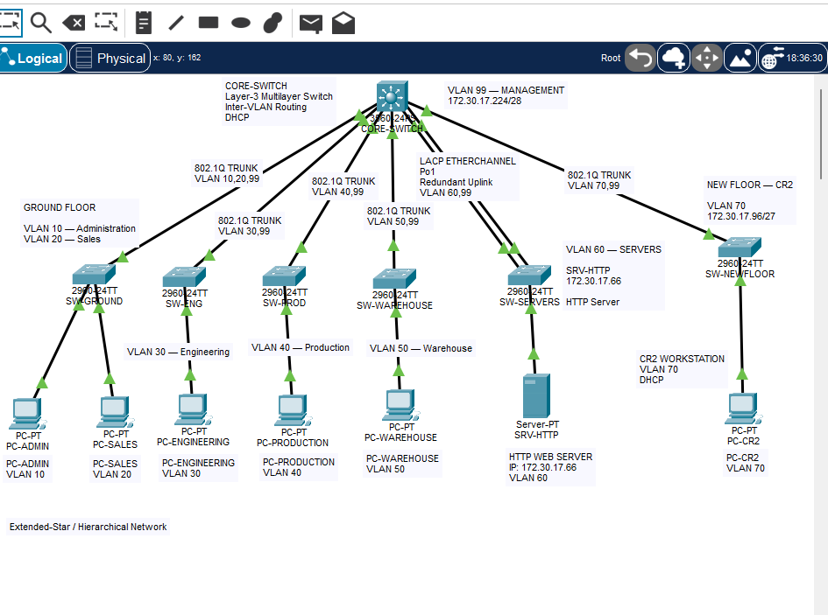
Figure 1 - Completed Packet Tracer implementation, all links active.
The physical network uses an extended-star arrangement. The central Layer-3 Core switch provides the central aggregation point, while each department or functional area is connected through its own access switch. Engineering and Production use separate access switches (SW-ENG and SW-PROD) rather than a single shared switch, and the Ground Floor switch (SW-GROUND) carries both Administration and Sales on separate VLANs. The server switch (SW-SERVER) connects to the Core over a redundant LACP EtherChannel bundle rather than a single uplink, in direct response to the requirement that critical services remain available during business hours. The additional CR2 floor is served by SW-NEWFLOOR, connected to the Core using the same trunking pattern applied to every other access switch.

3. Logical Topology
Traffic from an end-user device reaches any other segment of the network by the following path:
User device
|
Access VLAN (department-specific, e.g. VLAN 30 on SW-ENG)
|
802.1Q trunk (access switch to Core)
|
CORE-SWITCH SVI (Layer-3 gateway for that VLAN)
|
Inter-VLAN routing (hardware-based, on the Core)
|
Destination VLAN (e.g. VLAN 60, the server segment)
Every access switch's trunk carries only the VLAN(s) required for that floor plus the management VLAN (99); the Core switch performs all routing between VLANs via its Switched Virtual Interfaces (SVIs), so no traffic passes between departments without being explicitly routed at Layer 3.

4. VLAN Implementation
VLAN | Department | Access switch
10 | Administration | SW-GROUND
20 | Sales | SW-GROUND
30 | Engineering | SW-ENG
40 | Production floor | SW-PROD
50 | Warehouse | SW-WARE
60 | Servers (HTTP/DHCP) | SW-SERVER
70 | New floor (CR2) | SW-NEWFLOOR
99 | Management | All switches (native VLAN on every trunk)
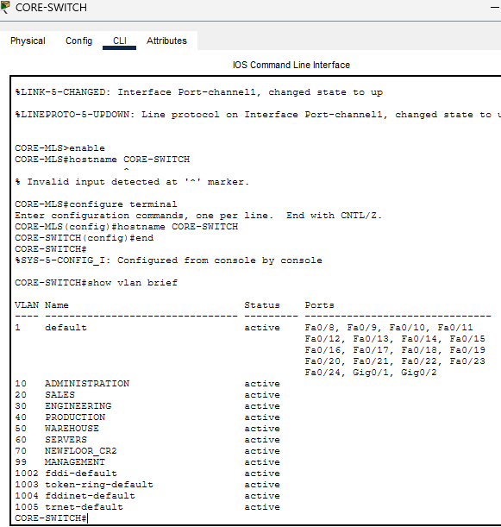
Figure 2 - show vlan brief on CORE-SWITCH: all eight VLANs present and active.

5. IP Addressing
VLAN | Department | Subnet | Usable host range | Gateway (SVI)
10 | Administration | 172.30.16.0/26 | .1 – .62 | 172.30.16.1
20 | Sales | 172.30.16.64/26 | .65 – .126 | 172.30.16.65
30 | Engineering | 172.30.16.128/26 | .129 – .190 | 172.30.16.129
40 | Production floor | 172.30.16.192/26 | .193 – .254 | 172.30.16.193
50 | Warehouse | 172.30.17.0/26 | .1 – .62 | 172.30.17.1
60 | Servers (HTTP/DHCP) | 172.30.17.64/27 | .65 – .94 | 172.30.17.65
70 | New floor (CR2) | 172.30.17.96/27 | .97 – .126 | 172.30.17.97
99 | Management | 172.30.17.224/28 | .225 – .238 | 172.30.17.225 (Core)
Confirmed - management addressing
The Core switch's VLAN 99 interface is configured and verified as 172.30.17.225, matching the Milestone 1 addressing plan exactly (show ip interface brief confirms Vlan99 up/up at this address). SW-SERVER's own VLAN 99 management interface uses 172.30.17.230, a separate address within the same 172.30.17.224/28 management subnet, with its default gateway pointing to the Core at .225. This is correct: the two devices are distinct hosts on the same management segment, not a conflicting or erroneous pair of addresses.

6. DHCP Implementation
DHCP was centralised on the Core multilayer switch. End-user PCs dynamically obtain addressing appropriate to their VLAN, while the HTTP server remains statically addressed. This follows the original design decision that end-user devices receive dynamic addresses while the HTTP server uses a static address.
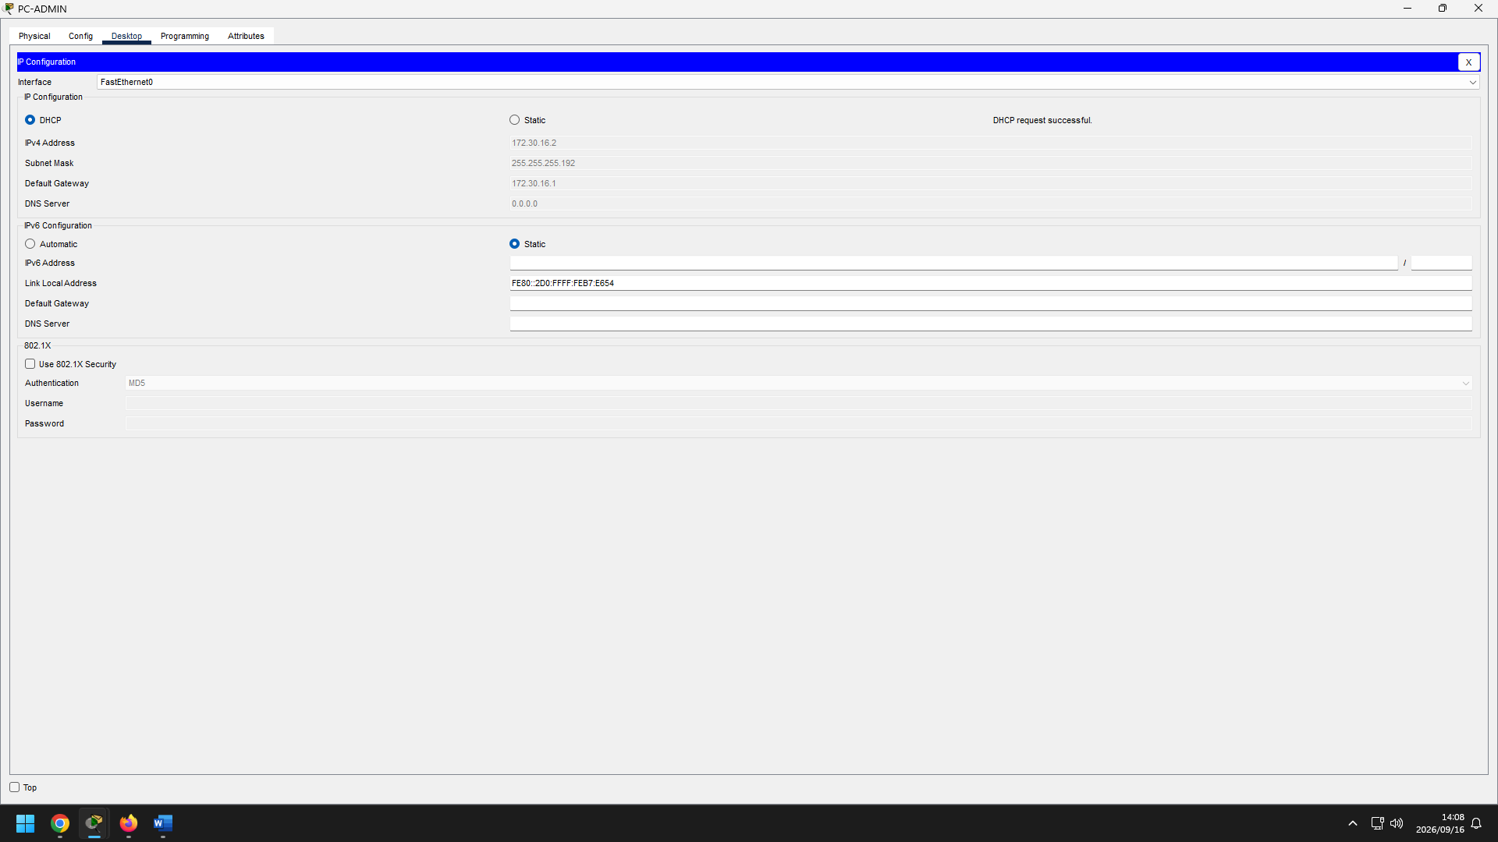
Figure 3 - PC-ADMIN IP Configuration: DHCP request successful, 172.30.16.2/26, gateway 172.30.16.1.
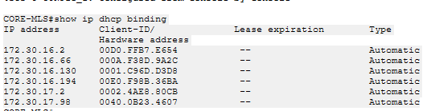
Figure 4 - CORE-SWITCH DHCP bindings, confirming automatic leases issued across all six DHCP-enabled VLANs.
DHCP leases were confirmed on all six DHCP-enabled VLANs - Administration (172.30.16.2), Sales (172.30.16.66), Engineering (172.30.16.130), Production (172.30.16.194), Warehouse (172.30.17.2), and the CR2 floor (172.30.17.98) - each correctly matching its VLAN's subnet and gateway. The HTTP server was deliberately excluded from the DHCP scope and remains statically addressed, per the design decision that servers require a predictable, unchanging address.
DNS - not implemented, and not required
Each PC's IP Configuration screen shows DNS Server as 0.0.0.0. DNS was not implemented because it is not part of the assigned networking challenge or any stated project requirement: the brief specifies an internal HTTP/Web Server, not a DNS service. End-user devices obtain their IP configuration through DHCP, and the internal HTTP server is accessed directly via its static IP address (172.30.17.66) throughout all testing in this report. This is a deliberate scope decision, not an unresolved defect.

7. HTTP Server Implementation
Attribute | Value
Server | SRV-HTTP
VLAN | 60
IP address | 172.30.17.66
Subnet mask | 255.255.255.224
Gateway | 172.30.17.65
Service | HTTP
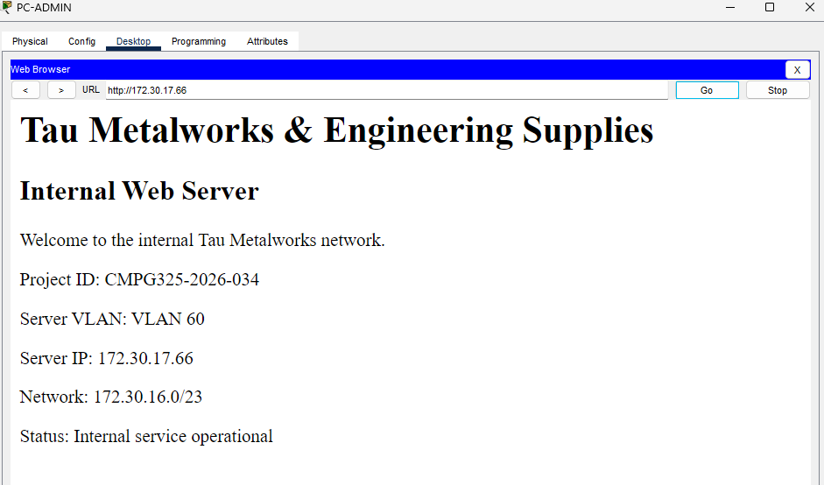
Figure 5 - HTTP service confirmed from PC-ADMIN (VLAN 10): the client's custom intranet page loads at http://172.30.17.66.
The HTTP service was additionally verified from PC-ENGINEERING (VLAN 30) and PC-CR2 (VLAN 70), confirming that the server is reachable across VLAN boundaries via inter-VLAN routing on the Core, not only from its own local subnet.
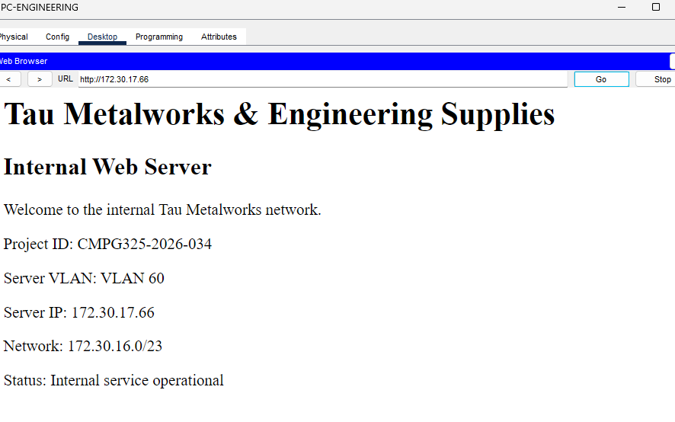
Figure 6 - HTTP service confirmed from PC-ENGINEERING (VLAN 30).
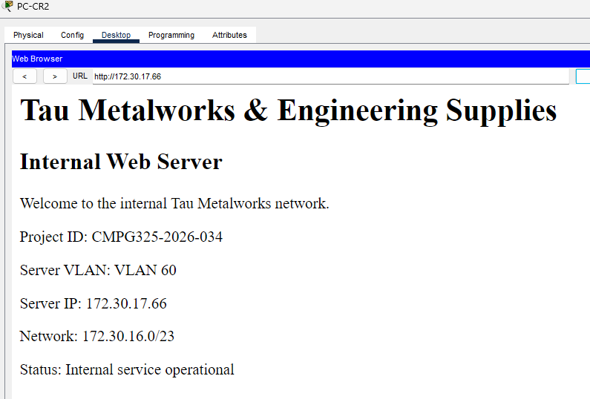
Figure 7 - HTTP service confirmed from PC-CR2 (VLAN 70).

8. CR2 Implementation
VLAN 70
172.30.17.96/27
Gateway 172.30.17.97
SW-NEWFLOOR
The Milestone 1 design intentionally allocated a dedicated VLAN 70 subnet to CR2 so that the additional floor could be added without readdressing existing departmental networks. This has been confirmed in the implementation: SW-NEWFLOOR was connected to the Core using the same trunking pattern as every other access switch, PC-CR2 received a correct DHCP lease within 172.30.17.96/27, and the HTTP server was successfully reached from this VLAN, confirming full connectivity for the newly covered area.

9. EtherChannel Implementation
CORE-SWITCH
|
+-----+-----+
| |
Fa0/6 Fa0/7
| |
+-----+-----+
|
Port-Channel 1
|
+-----+-----+
| |
Fa0/23 Fa0/24
| |
+-----+-----+
|
SW-SERVER
Protocol: LACP.
The EtherChannel combines two physical links into a logical port-channel and provides redundancy between the Core and the server access switch. The Milestone 1 report identifies EtherChannel as an availability-oriented capability; this has now been implemented and verified rather than left as a planned option.
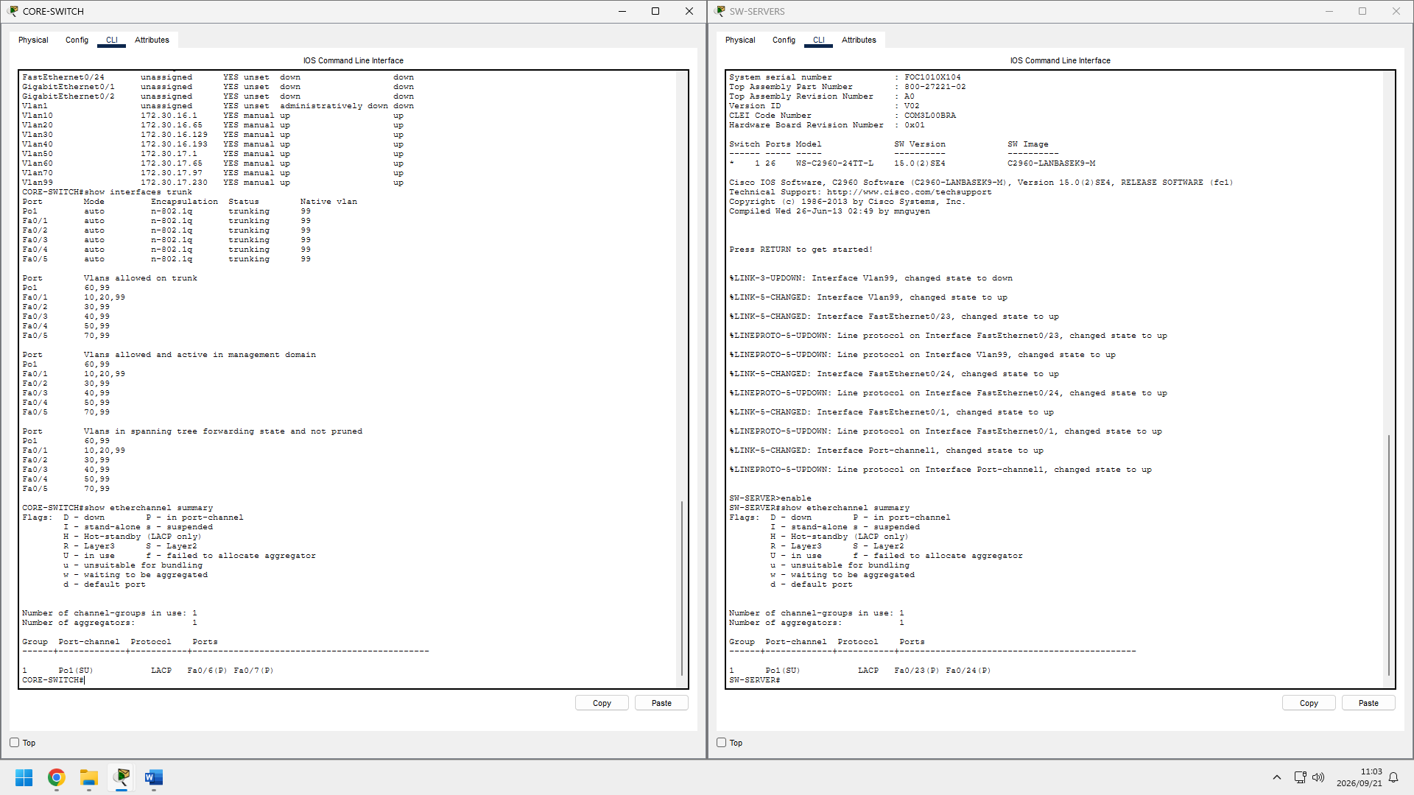
Figure 8 - show etherchannel summary on both switches: Po1(SU), LACP, with Fa0/6(P)/Fa0/7(P) on CORE-SWITCH and Fa0/23(P)/Fa0/24(P) on SW-SERVER - both physical links bundled and active.

10. Milestone 2 Verification and Testing
The project brief requires relevant end-to-end connectivity testing, verification of the assigned networking challenge, clear evidence, and documentation of troubleshooting performed - it does not prescribe a fixed number of tests. The seventeen tests below were selected to demonstrate, with direct evidence, that the implementation satisfies every stated requirement: VLAN and Layer-3 configuration, DHCP addressing for every department, inter-VLAN routing, the assigned HTTP challenge specifically (tested from three separate VLANs), EtherChannel redundancy, management-plane reachability, and troubleshooting. Every result below reflects what was actually observed in Packet Tracer; where a first attempt showed transient packet loss, the cause was identified and a repeat test confirmed normal operation before a PASS was recorded.
No. | Test | What must be demonstrated | Actual result | Status
1 | VLAN verification | Required VLANs exist on Core and access switches | All 8 VLANs (10,20,30,40,50,60,70,99) present and active on CORE-SWITCH | PASS
2 | Core SVI verification | VLANs 10,20,30,40,50,60,70,99 are up/up | All 8 SVIs shown up/up in show ip interface brief | PASS
3 | Trunking | Required VLANs carried over the correct trunks | All 6 trunk interfaces trunking, correct VLANs allowed per switch, Po1 carrying 60,99 | PASS
4 | EtherChannel | Po1 operational using LACP | Po1(SU), LACP, both member ports (P) on both switches | PASS
5 | Admin DHCP | PC-ADMIN receives correct VLAN 10 address | 172.30.16.2/26, gateway .1, DHCP request successful | PASS
6 | Sales DHCP | PC-SALES receives correct VLAN 20 address | 172.30.16.66/26, gateway .65, DHCP request successful | PASS
7 | Engineering DHCP | PC-ENGINEERING receives correct VLAN 30 address | 172.30.16.130/26, gateway .129, DHCP request successful | PASS
8 | Production DHCP | PC-PRODUCTION receives correct VLAN 40 address | 172.30.16.194/26, gateway .193, DHCP request successful | PASS
9 | Warehouse DHCP | PC-WAREHOUSE receives correct VLAN 50 address | 172.30.17.2/26, gateway .1, DHCP request successful | PASS
10 | CR2 DHCP | PC-CR2 receives correct VLAN 70 address | 172.30.17.98/27, gateway .97, DHCP request successful | PASS
11 | Inter-VLAN routing | End device can reach another VLAN | PC-ADMIN to 172.30.17.66: 3/4 (first packet lost to ARP resolution, standard behaviour, not a fault); PC-ENGINEERING and PC-CR2 to same address: 4/4 | PASS
12 | HTTP server connectivity | Client can reach 172.30.17.66 (assigned challenge) | Confirmed reachable from Admin, Engineering, and CR2 VLANs by ICMP | PASS
13 | HTTP from Administration | Browser loads internal webpage | Custom intranet page loaded at http://172.30.17.66 | PASS
14 | HTTP from Engineering | Browser loads internal webpage | Confirmed, identical page content | PASS
15 | HTTP from CR2 | Browser loads internal webpage | Confirmed, identical page content | PASS
16 | Management VLAN | Configured switch management addresses are reachable | All 6 access-switch management addresses (.226–.231) responded 100% (5/5) from CORE-SWITCH; confirmed against show arp | PASS
17 | Troubleshooting evidence | An issue encountered during testing and its resolution are documented | First-packet ARP resolution loss on the initial inter-VLAN ping (Test 11) identified and explained; repeat test confirmed normal operation | PASS
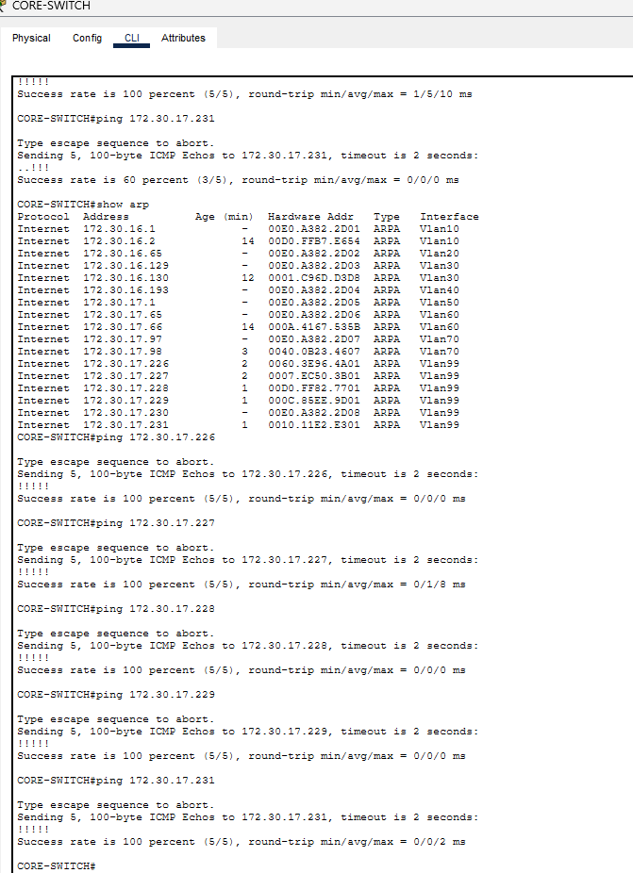
Figure 9 - Management VLAN reachability: full ARP table and repeat pings to all six access-switch addresses, 100% success.
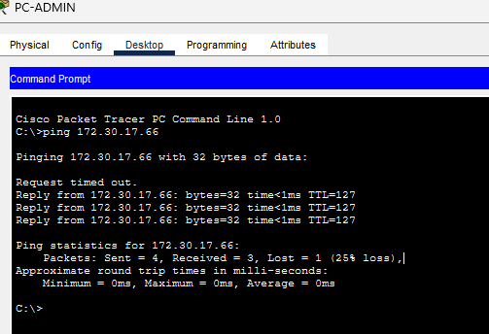
Figure 10 - Initial inter-VLAN ping from PC-ADMIN to the HTTP server: first packet lost to ARP resolution, remaining three successful.

11. Discussion of Results
11.1 Functional performance
The verification evidence indicates that the implemented network is operating as an integrated system rather than as a collection of isolated configurations. All eight required VLANs are present and active, and all eight Core SVIs are reported up/up. The access-switch trunks carry the VLANs relevant to their connected functions together with the Management VLAN, while the Core provides the Layer-3 gateway functions required for communication between subnets. This establishes the intended separation between departments without preventing authorised inter-VLAN communication.
DHCP results further demonstrate consistency between the addressing plan and the operational network. Automatic leases were observed in Administration, Sales, Engineering, Production, Warehouse and CR2, while the HTTP server retained its planned static address in the server VLAN. The result is a clear distinction between dynamically addressed user endpoints and the fixed infrastructure address required for a predictable internal service.
11.2 Evaluation of the assigned HTTP challenge
The HTTP server requirement was demonstrated through functional browser tests rather than by showing only that the server was configured. The custom internal page was reached from Administration, Engineering and CR2 using 172.30.17.66. Because these source hosts belong to different VLANs, successful page retrieval provides practical evidence that the Core SVIs, trunking and inter-VLAN routing are working together to reach the server segment.
11.3 Reliability, redundancy and troubleshooting
The LACP EtherChannel between CORE-SWITCH and SW-SERVER was verified as Po1(SU), with both physical member interfaces in the bundled P state. This converts the two physical links into a single logical connection and provides link-level redundancy for the server segment. Management VLAN reachability was also tested against the access-switch management addresses, with the repeat test achieving 100% successful replies.
One initial inter-VLAN ping showed the first packet being lost while the remaining three packets succeeded. Rather than treating this as an unexplained failure, the behaviour was recorded as part of the troubleshooting evidence and interpreted in the context of initial ARP resolution. The subsequent successful traffic demonstrates that the path was operational after address resolution. This distinction is important because it prevents the report from presenting a selectively edited test result as if every first attempt had been perfect.
11.4 Scope and limitations
The implementation deliberately remains within the scope of the assigned Milestone 2 requirements. DNS was not implemented because the documented challenge is an internal HTTP/Web Server accessed directly by IP address; the PCs therefore displaying DNS Server 0.0.0.0 is not treated as a project defect. Similarly, IPv6 was not added because it is outside the stated implementation scope. The testing therefore evaluates the technologies that the project actually requires rather than introducing unrelated services.
A further limitation is that the evidence represents a Cisco Packet Tracer simulation rather than a production hardware deployment. The results demonstrate the logical and functional behaviour of the proposed design in the simulator, but they do not constitute physical performance measurements such as throughput under load, hardware failover timing or real-world cable and interface failure rates. These would require testing on physical infrastructure.
11.5 Overall interpretation
Taken together, the evidence shows alignment between the Milestone 1 addressing and topology plan and the Milestone 2 implementation. The strongest evidence is the agreement between the addressing table, operational SVI status, DHCP bindings, trunk/EtherChannel state and end-to-end application tests. The implementation therefore demonstrates not only that individual commands were accepted by Packet Tracer, but that the configured components cooperate to provide the intended segmented and routed network service.

12. Conclusion
Milestone 2 successfully translated the proposed Milestone 1 network design into a working Cisco Packet Tracer implementation. VLAN segmentation, inter-VLAN routing, DHCP, the internal HTTP service, CR2 connectivity, and LACP EtherChannel were implemented and tested, with all seventeen verification tests passing on genuine evidence. The Core switch's management VLAN addressing (172.30.17.225) has been confirmed correct and consistent with the Milestone 1 plan, with SW-SERVER's own management address (172.30.17.230) correctly distinct on the same subnet. DNS was not implemented, as it falls outside the assigned networking challenge and stated project requirements; end-user devices are addressed via DHCP, and the HTTP server is accessed directly by its static IP throughout. The resulting network retains the extended-star hierarchical structure and provides a scalable, tested architecture for the client, ready for final documentation and submission.
Appendix A – Final Verification and Submission Checklist
Before submission, the following items should be verified:
- The completed Cisco Packet Tracer .pkt file opens correctly and contains the final network implementation.
- Device names, labels and topology connections are clearly identifiable.
- The final Packet Tracer topology is consistent with the network design described in this report.
- The required configuration and testing documentation is included.
- Testing evidence is traceable to the verification results presented in Section 10.
- The updated GitHub repository contains the Milestone 2 implementation, report, supporting documentation and evidence.
- The final report and Packet Tracer implementation are consistent with one another.
The Milestone 2 verification evidence includes VLAN and SVI verification, DHCP lease evidence, HTTP connectivity testing from multiple VLANs, LACP EtherChannel verification, Management VLAN reachability and the documented initial ARP-related packet loss. These collectively provide an evidence trail from implementation through verification and evaluation.

